*VARIABLE DC REGULATED POWER SUPPLY*

**Ravi L**   
*Electronics and Communication   
The National Institute of Engineering*  
*Mysuru, Karnataka, India*   
2023ec_ravil_b@nie.ac.in

**Rishi Pushkar P**   
*Electronics and Communication   
The National Institute of Engineering*  
*Mysuru, Karnataka, India*   
2023ec_rishipushkarp_b@nie.ac.in

**Priyanka S**   
*Electronics and Communication   
The National Institute of Engineering*  
*Mysuru, Karnataka, India*   
2023ec_priyankas_b@nie.ac.in**Nikhil K M**   
*Electronics and Communication   
The National Institute of Engineering*  
*Mysuru, Karnataka, India*   
2023ec_nikhilkm_b@nie.ac.in

***Abstract*—a variable DC regulated power supply is our project that consists of bridge rectifier *,*transformer, transistors,BJT,capacitors, etc. A variable DC regulated power supply using a transistor operates by converting an unregulated DC voltage into a stable, adjustable output voltage. The circuit typically employs a series-pass transistor, such as a BJT (Bipolar Junction Transistor) or MOSFET, controlled by a voltage regulator circuit. The regulator adjusts the transistor’s base or gate voltage to maintain a constant output voltage, regardless of variations in input voltage or load conditions. A potentiometer is often included to allow the user to vary the output voltage. The design also incorporates components like a rectifier, filter capacitor, and feedback loop for regulation, ensuring smooth and noise-free DC output suitable for powering electronic devices and circuits.**

**Introduction**

. The project is to develop a variable DC regulated power supply which we tried to develop without using IC’s and zener diodes which only consists of normal transistors, diodes,capacitors,risistors and etc. So our project is to be done in low cost also and keeping mind about its efficiency and quality.Our project is to build a voltage regulator that should be regulated .as our requirements.A Variable DC Regulated Power Supply using transistors is an electronic device designed to deliver a stable and adjustable DC voltage to a load. It employs transistors as active components for regulation, ensuring precise control over the output voltage and current. The circuit typically includes a rectifier to convert AC to DC, a filter to remove ripples, and a transistor-based regulator to maintain a constant output, even with variations in input voltage or load conditions. Widely used in laboratories and electronic testing, it offers flexibility and reliability for powering diverse electronic devices and systems.

This project of voltage regulator consists so many keywords or key moments which is very necessary to understand how this regulator works. There are like rectification from bridge rectifiers ,filters by capacitors,voltage regulation by transistors using negative feedback circuit etc.

**Rectification:**  Rectification is the process of converting alternating current (AC) into direct current (DC). This is achieved using electronic components such as diodes, which allow current to flow in only one direction. The rectification process can be classified into half-wave rectification, where only one half of the AC waveform is converted, and full-wave rectification, which converts both halves of the AC waveform into DC. Rectification is a crucial step in power supply circuits, enabling AC from the mains to be transformed into the DC required for operating electronic devices and systems.

**Filtering by capacitors:**Filters using capacitors are essential components in power supply circuits, designed to smooth out the pulsating DC output from the rectification process. Capacitors achieve this by storing energy during the peaks of the rectified voltage and releasing it during the dips, thereby reducing voltage fluctuations and ripples. This creates a more stable and consistent DC output, suitable for powering electronic devices. Capacitor filters are simple, cost-effective, and widely used in combination with other components, such as resistors or inductors, to enhance the overall performance of power supply systems.

**negative feedback:**

A negative feedback regulator is a system used in electronics to maintain a stable output voltage or current by automatically correcting deviations from the desired level. In this system, a portion of the output is fed back to the input in reverse phase (negative feedback) and compared with a reference signal. If the output deviates from the set value, the feedback signal adjusts the regulator’s operation to minimize the error and bring the output back to its intended level. This mechanism ensures precise regulation, enhances stability, reduces noise, and improves overall performance in applications such as power supplies and amplifiers.

this is all about the brief introduction about the a variable DC regulated power supply.Letus understand the components used in this DC voltage regulator.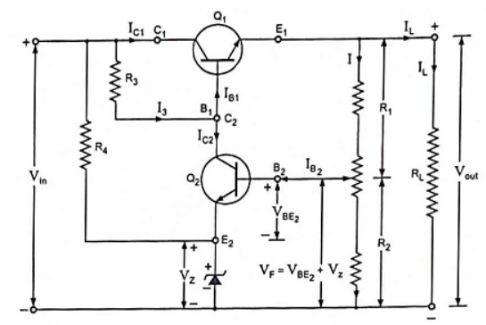

**CIRCUIT DESIGN:**

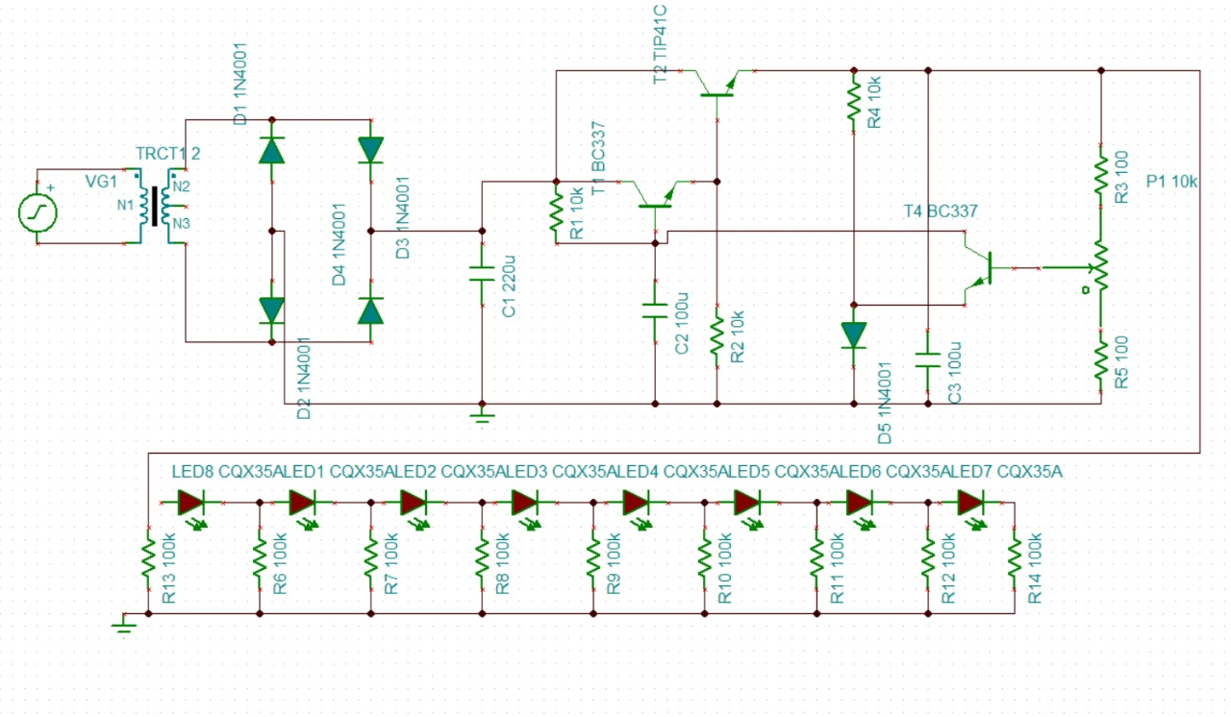

This consists this following components

* Diodes:1N4001-5
* Transformer:24-0-24:-1
* Capacitors:2200,100 microfarad:-1-2
* Resistors:10k,1k,100 ohm:-2-1-2
* Potentiometer:10k-1
* BJT:BC337,TIP41C:-2-1
* AC input-1
* LED-8

**Simulation :**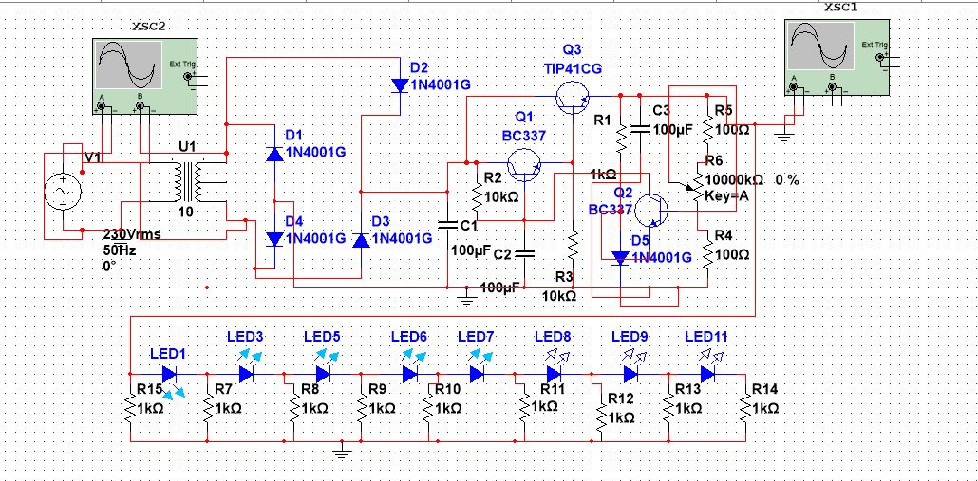

the circuit will get the input from AC 230 rms voltage of 50Hz .The transformer steps down the mains voltage (220V/117V AC) to 24V AC.The bridge rectifier (D1–D4) converts the 24V AC into pulsating DC. During each half-cycle of AC, two diodes conduct to ensure unidirectional current.The large filter capacitor (C1, 2200 µF) charges during the peaks of the pulsating DC and discharges during the dips, providing a relatively steady DC voltage.Q1 (BC337): Acts as a buffer and helps amplify the small current to drive the power transistor (Q3).Q2 (BC337): Serves as the main control transistor.The base voltage of Q2 is set using the potentiometer (VR1).Here BC337 which is a BJT is normal transistor which is for negative feedback and amplification.The emitter voltage of Q2 is approximately equal to its base voltage minus a small base-emitter voltage drop (around 0.7V).

This emitter voltage determines the base voltage of Q3, thereby controlling its conduction.Q3 (TIP41): A power transistor that handles high current demands.

INPUT SIGNAL

OUTPUT WAVEFORM: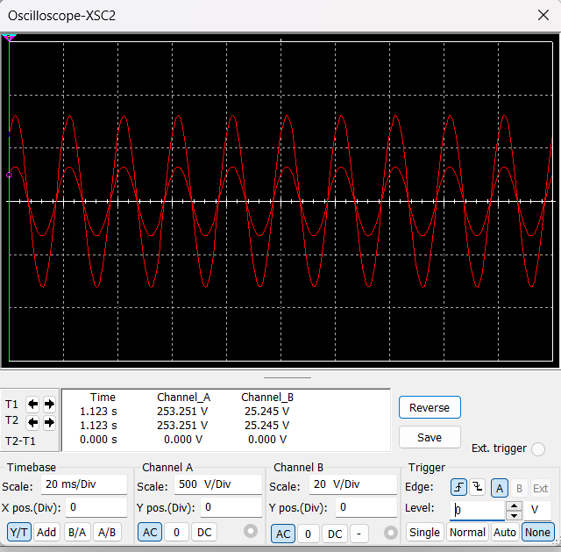

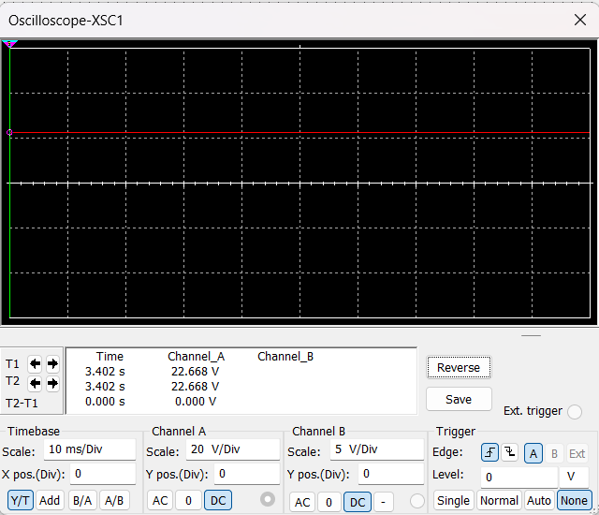

The input and output waveforms of a voltage regulator illustrate its ability to maintain a stable output voltage regardless of variations in the input voltage or load conditions. The input waveform is typically an unregulated DC voltage, which may have ripples or fluctuations resulting from the rectification process. The output waveform, on the other hand, is a steady, smooth DC voltage with minimal or no ripples, showcasing the regulator’s effectiveness. This transition from a fluctuating input to a constant output is achieved through components such as transistors, diodes, and feedback mechanisms, ensuring reliable performance for powering sensitive electronic circuits.

**Circuit Explanation:**

**1. Step-Down Transformer:** A transformer reduces the input AC voltage (220V/117V) to 24V AC suitable for rectification.

**2. Bridge Rectifier:** Four diodes (D1–D4, 1N4001) form a bridge rectifier to convert the 24V AC into pulsating DC. During each half-cycle, two diodes conduct to provide a unidirectional current.

**3. Smoothing Capacitor (C1):** The large electrolytic capacitor (C1, 2200 µF) smoothens the pulsating DC output from the rectifier by storing charge during peaks and discharging during valleys.

**4. Voltage Control and Regulation:** Q1 (BC337): Acts as a pre-regulator and provides base drive to the power transistor Q3. Q2 (BC337): Works as a control transistor to regulate output voltage. Its base voltage is adjusted by the potentiometer (VR1), which determines the output voltage. Q3 (TIP41): A power transistor that handles high output current and delivers it to the load.Feedback through Q2 ensures stable output voltage**.**

**5. Protection (D5):** D5 (1N4001) prevents reverse voltage from damaging the circuit in case of incorrect polarity connection.

**6. Stabilizing Capacitors (C2, C3):** Capacitors C2 and C3 (100 µF) filter out any remaining ripple and noise, ensuring a clean DC output.

**7. Voltage Adjustment: The potentiometer (VR1, 10kΩ) adjusts the base voltage of Q2, which changes the emitter voltage of Q2 and Q3, thus varying the output voltage (0–30V).**

**8. Load Handling: R5 (1kΩ) limits the base current of Q3 to protect it from overloading.**

**R1 and R2 (10kΩ) provide biasing for Q1 and Q2, ensuring proper operation.**

# **Working principle:**

**1. Step-Down and AC-DC Conversion:**

The transformer steps down the mains voltage (220V/117V AC) to 24V AC.

The bridge rectifier (D1–D4) converts the 24V AC into pulsating DC. During each half-cycle of AC, two diodes conduct to ensure unidirectional current.

**2. Smoothing the Rectified DC:**

The rectified DC is not smooth and contains ripples.

The large filter capacitor (C1, 2200 µF) charges during the peaks of the pulsating DC and discharges during the dips, providing a relatively steady DC voltage.

**3. Voltage Control Using Transistors:** Q1 (BC337): Acts as a buffer and helps amplify the small current to drive the power transistor (Q3). It also reduces the load on Q2 and ensures stable operation.

Q2 (BC337): Serves as the main control transistor.

The base voltage of Q2 is set using the potentiometer (VR1).

The emitter voltage of Q2 is approximately equal to its base voltage minus a small base-emitter voltage drop (around 0.7V).

This emitter voltage determines the base voltage of Q3, thereby controlling its conduction.

**4. Power Amplification:** Q3 (TIP41): A power transistor that handles high current demands.

The output voltage at the emitter of Q3 depends on the voltage at its base, which is controlled by Q2.

Q3 acts as the main current source, delivering the required current to the load.

**5. Voltage Adjustment:** The potentiometer (VR1, 10kΩ) allows the user to adjust the base voltage of Q2. As the base voltage of Q2 changes, the emitter voltage of Q2, and hence the base voltage of Q3, changes accordingly.

This varies the output voltage, providing a range of 0V to approximately 30V.

**6. Feedback for Regulation:** Feedback through Q2 ensures the output voltage remains stable even if the load changes.

Any increase in output current causes a slight voltage drop across R5 and R4, which adjusts Q2’s operation to stabilize the output voltage.

**7. Ripple Reduction:** Capacitors C2 and C3 (both 100 µF) further smoothen the output voltage by filtering high-frequency noise and ripples.

**8. Protection:**Diode D5 (1N4001) prevents reverse voltage from damaging the circuit. If the output terminals are accidentally connected in reverse, D5 blocks the reverse current.

**9. Current Limiting:** Resistor R5 (1kΩ) limits the base current to Q3, protecting it from excessive current.Resistors R1 and R2 (10kΩ) ensure proper biasing for Q1 and Q2.

**Methodology**

**1. Step-Down Voltage:** Use a transformer to step down 220V/117V AC to 24V AC.

**2. AC to DC Conversion:** Employ a bridge rectifier (D1–D4) to convert the 24V AC to pulsating DC.

**3. Filtering:** Smooth the pulsating DC with a large electrolytic capacitor (C1, 2200 µF) to reduce ripple.

**4. Voltage Regulation and Adjustment:** Use Q1 (BC337) and Q3 (TIP41) to amplify current and regulate output voltage.Adjust output voltage using the potentiometer (VR1), which sets the base voltage of Q2. Q2 (BC337) provides feedback and stabilizes the voltage.

**5. Protection:** Add D5 (1N4001) for reverse polarity protection to prevent damage to components.

**6. Final Smoothing:**  Use C2 and C3 (100 µF capacitors) to further reduce ripple and noise in the output.

**7. Output Voltage:** The circuit provides a variable DC output (0V to 30V), adjusted by VR1.

**Testing:** Verify the output voltage range with a multimeter. Test the circuit with different loads to ensure stability

**Negative feedback circuit:**

A controlled transistor series regulator .This Controlled Transistor Series Regulator circuit is quite similar to that of a simple transistor series voltage regulator except that an additional transistor Q2 is inserted in the circuit. The emitter terminal of this transistor Q2 is connected to the negative terminal of input supply through a zener diode. The base of this additional transistor is connected to the variable tap of a potentiometer.

This voltage regulator employs the principle of negative feedback to hold the output voltage almost constant despite variations in supply voltage and/or load current. That is why this regulator is also called a negative feedback regulator.

Transistor Q1, the control element, is called the pass transistor because all the load current flows through it. Zener diode and resistor R4 act as a reference element. The voltage divider (or potentiometer) consisting of resistors R1 and R2 samples the output voltage and delivers a negative feedback voltage to the base of transistor Q2 and this feedback voltage (VF = VBE2 + Vz) controls the collector current of transistor Q2.

### **Operation:**Suppose the output voltage increases (due to any reason), the voltage across R2 is also increased as it is part of the output circuit. This causes an increase in voltage (VBE2 + Vz). As a result IB2 and also IC2 increases. Assuming I3 relatively constant, IB1 decreases. Decrease in base current of transistor Q1 causes the increase in collector-emitter resistance of transistor Q1. This causes an increase in VC1E1 thereby off-setting the increase in output voltage. Thus output voltage remains constant.Reverse happens should the output voltage decrease.The voltage V2 provided by the potential divider R1-R2 must be equal to the sum of the base-emitter voltage of transistor Q2 and the zener diode i.e.

### ,Like emitter follower regulator this regulator also has the drawback of excessive power dissipation. Due to this high power dissipation output of the power supply is limited to 30-40 V, as safe value of VCE is 50 V.

### Another drawback of this regulator is that it has no overload/short-circuit protection.

**Result:**

voltage regulator circuit on breadboard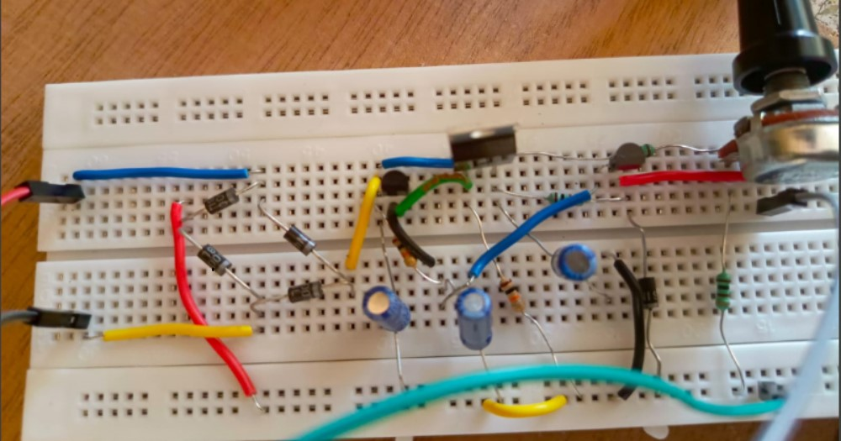

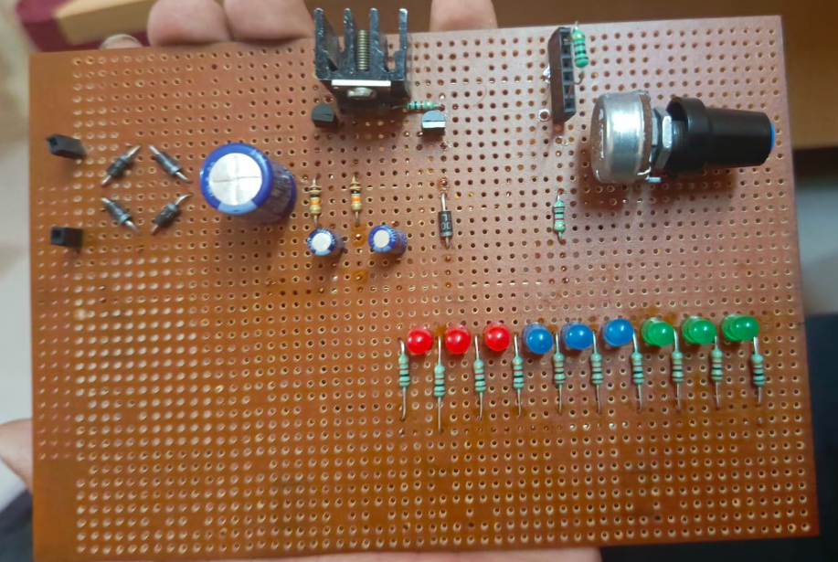

voltage regulator circuit on PCB

Estimated Budget details

● Diode-₹2×5=₹10

● Capacitors- ₹10× 3 = 30₹

● NPNBipolar Transistor- ₹20 × 3 =₹ 60

● Resistor- ₹10× 1 = ₹10

● Potentiometer- ₹15× 1 = ₹15

● Transformers- ₹200× 1=₹200

The total project cost that comes near to 500 rupees on average , which is a reasonable cost for this project .As we compare the price of ready made variable DC power supplier is near to 6500 to 10000 rupees which is very expensive . so we think it is worthy to construct this project

**Importance:**

As earlier mentioned the importance of the DC variable power supply ,all the electronic equipment,components,devices all are dependent on the DC for conduction and also they need to do their respective work DC supply is essential for them. so we can easily see the importance and we can predict the contribution of this project. Basically our project is to construct a variable DC power supplier that should be more efficient ,user friendly, average budget.So this project will contribute in efficiency , lifespan, proper work of the electronic components that are present in the electronic devices

**Schedule:**

The project schedule for the variable DC power supply includes an initial phase of research and planning to define specifications, followed by designing the circuit schematic and selecting components. Afterward, we’ll proceed with prototyping, testing, and refining the circuit, followed by creating a PCB layout and assembling it, if needed. Once the prototype is tested and optimized for performance, the final assembly and packaging will be completed, including housing design and control interfaces. The final stages involve comprehensive testing, documentation, and preparation of a report and presentation, culminating in a final review before submission

**Reference:**

[1] A.Sedra, K.C. Smith,T.chan Carusone,V.Gaudet,Microelectronic Circuits,8th ed.,Nijwm Wary ,2019. [2]https://forum.allaboutcircuits.com/threads/ac-to-dc-power-supply-without-an-ic.

[3] Bahzad Razavi,Fundamentals of Microelectronics,2nd ed.,Wiley, 2013. [4]https://en.wikipedia.org/wiki/Diode. [5]http://en.wikipedia.org/wiki/Capacitor. [6]http://en.wikipedia.org/wiki/Rectifier. [7]http://www.electronics-hub.com